# Star Wars Collectibles eCommerce – Presentation

## Script

Introduction of Team

Opening Comments - Cash

* Project Theme – Star Wars Collectibles
* Styling Guidelines – Material UI

Standard for Android development, Google, Popular with Web App design

* + Google **Android** and **Apple iOS** have 98% of the global **market share** for operating systems. **Android's market share** will reach 87% in 2022, forecasts suggest. So far, the **iOS market share** in 2019 is 22.17%
* Method of presentation: Sequencing through each team member

Login & Seller – Demetrice

* Register 1 user
* Login as buyer
* Demonstrate Product Filter
  + Search for Han Solo by typing in “Han” (erase all the way and it will re-render)
  + Search for Video Games by typing in “Video” (erase all the way and it will re-render)
* Add to Cart (Mention – don’t show)
* Product Detail View Page
* Add to Cart Button
* Demonstrate the Review & Rating options
* Log Off

Product & Category – Rich

* Log in a Seller (JApple)
* Note differences Appbar, Add Product, Categories
* Pull up ADD products page (cash keys in values, adds and then routes to the product list from the navbar)
* In product list show that the added product is now visible.
* Log off and Relog in as a JDoe

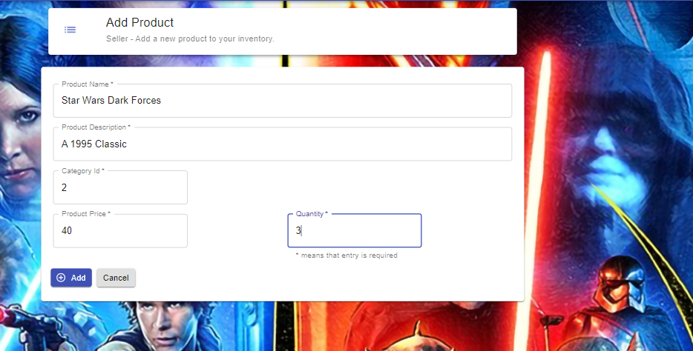

Shopping Cart – Steve

* Demo Shopping Cart
* Add to Cart
* Increment-Decrement count
* Show Product Details
* Delete a product

Checkout, Order History, & Mobile Navigation – Cash

* Checkout - Stepper Screens – Allows for entry of shipping order info, payment, & review.
* Order History/Detail – Allows for next scrum cycle of Seller Analysis
* Mobile Navigation – Responsive screens and mobile menu.

Closing Comments – Cash

* Accomplished MVP and setup for next phase of development
* Additional targeted Ideas
  + Adding images for projects
  + Paypal/GooglePay/ApplePay and other Vendor integration
  + User selected theme: Dark, Relay, or even company specific (e.g. “Moonlight” or “Owl”)
  + Line Chart analysis of product sales
  + Internal app Notifications
  + Email integration: External & App Internal
  + Order/Shipping Tracking
  + User Profile Details Edit

Q/A - Everyone